Step 1: Problem Segregation

1. The problem is segregated into two different models, one using the Cov3D and other one using the Conv2d + RNN
2. Ran 24 experiments on Conv3d and 18 experiments using Conv2d + RNN with different Hyper parameters

Step 2: Tool Usage

1. Because there were 42 experiments overall and it was hard to track, I used Mlflow tracking which helped me track the experiments also compare the overall results
2. Here is the link for more details <https://www.mlflow.org/docs/latest/tracking.html>

Step 3: Directory Structure

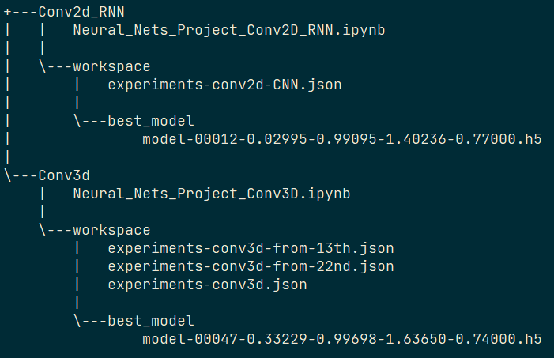

*Contains 2 ipynb files for respective models, /workspace has the /best_model in .h5 file and also /workspace has experiment configurations in .json file*

Step 4: Experiments Details

Key considerations:

* Keeping Batch size to 16, because of **ResourceExhaustedError**

**Experiment with conv2d + RNN Model**

Following are the parameters are considered to run experiments

1. **minimumLearningRate**: lower bound on the learning rate.
2. **learningRateFactor**: 0.1, 0.15, 0.2 (factor by which the learning rate will be reduced. new_lr = lr * factor)
3. **optimizer**: SGD, Adagrad, Adam
4. **numberOfEpochs**: 20, 50

I have externalized the experiments, details are in **experiments-conv2d-RNN.json**, which is specific to the model with Conv2d + RNN to segregate the experiments. More details in appendix section

**Experiment with conv3d**

Following are the parameters are considered to run experiments

1. **minimumLearningRate**: lower bound on the learning rate.
2. **learningRateFactor**: 0.1, 0.15, 0.2 (factor by which the learning rate will be reduced. new_lr = lr * factor)
3. **optimizer**: SGD, Adagrad, Adam
4. **numberOfEpochs**: 20, 50

I have externalized the experiments, details are in **experiments-conv3d.json**, which is specific to models with Conv3D and MaxPooling3D to segregate the experiments. More details in appendix section

#### *Due to disk space limitations, I was unable to run completely at once. After cleaning up, I resumed from the 13th experiment and the 22nd. That’s why there are 3 json files*

Step 5: Experiment Outcomes using Conv3d

**Overall Runs**

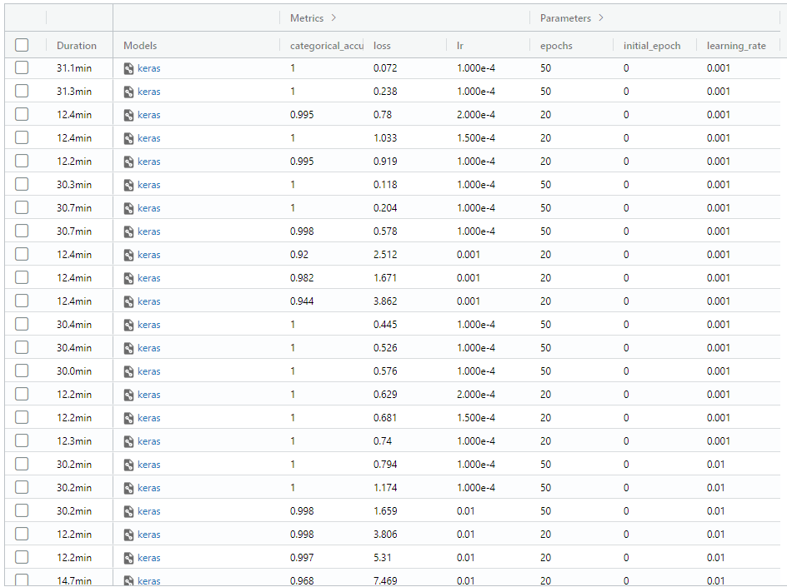

**Observations**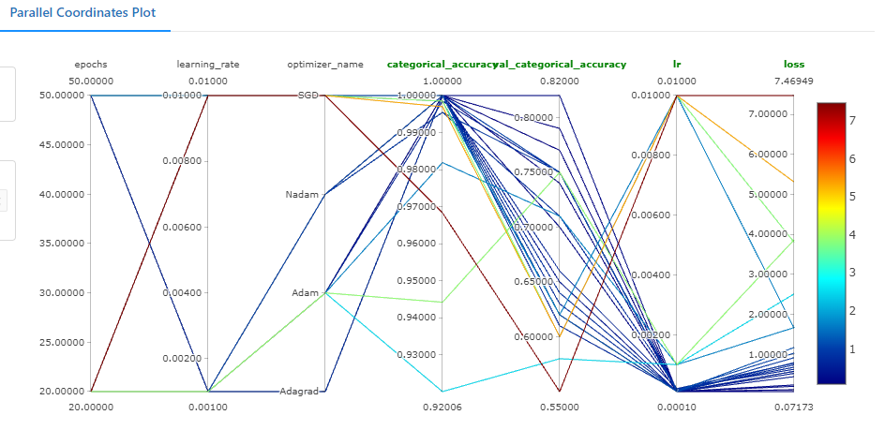

From the parallel coordinate plot, we can see that higher number of epochs (50), lower learning rate (0.001),lower lr factor, Optimizer Nadam & Adagrad performed very well.

**Best vs Worst with respect to Loss**

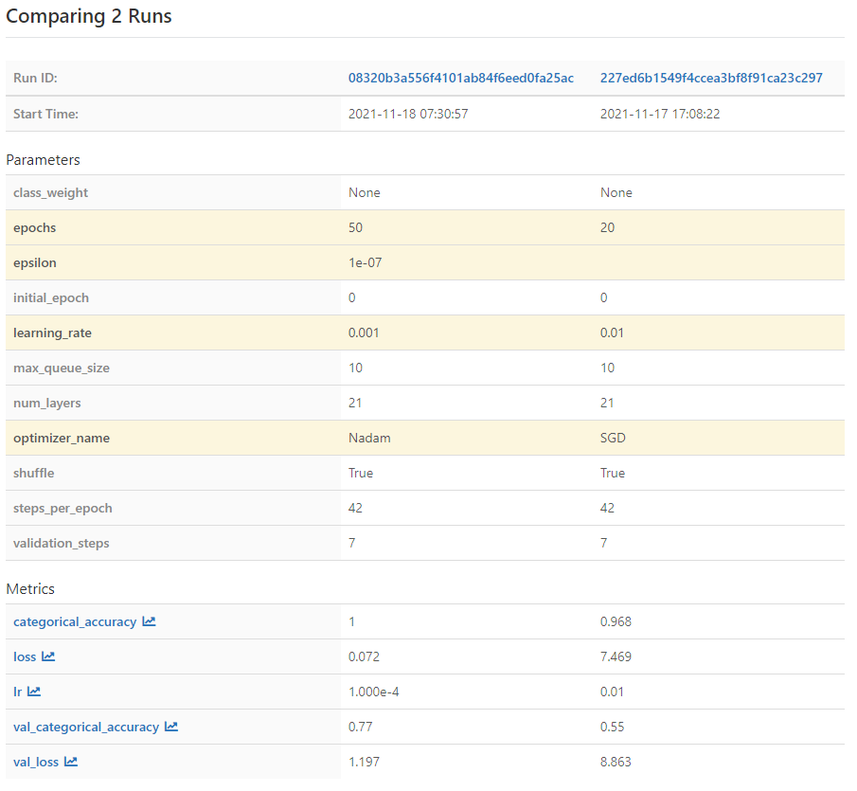

**Best vs Worst with respect to Validation categorical accuracy**

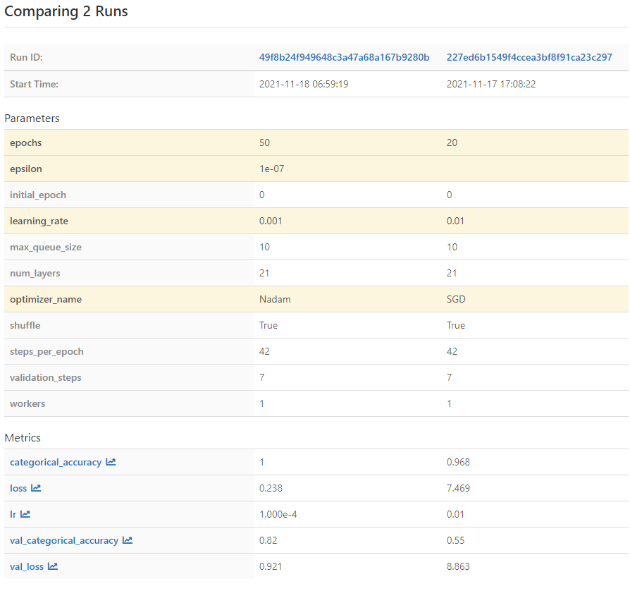

Step 6: Experiment Outcomes using Conv2d+RNN

**Overall Runs**

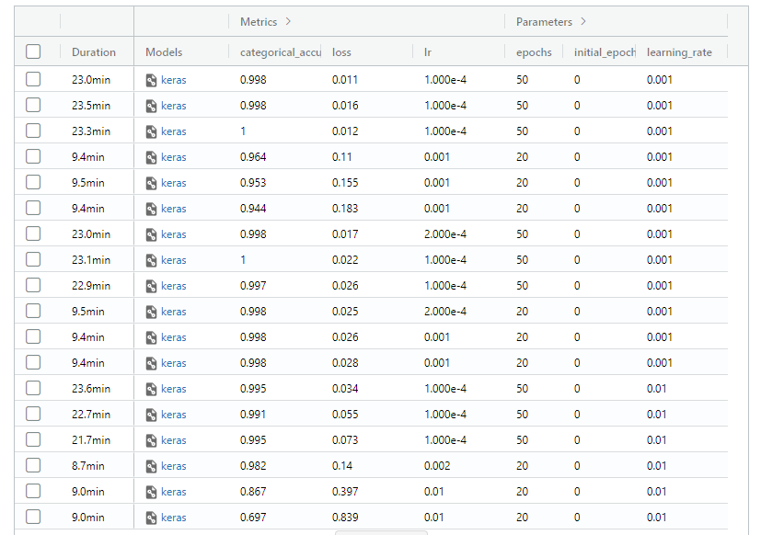

**Observations**

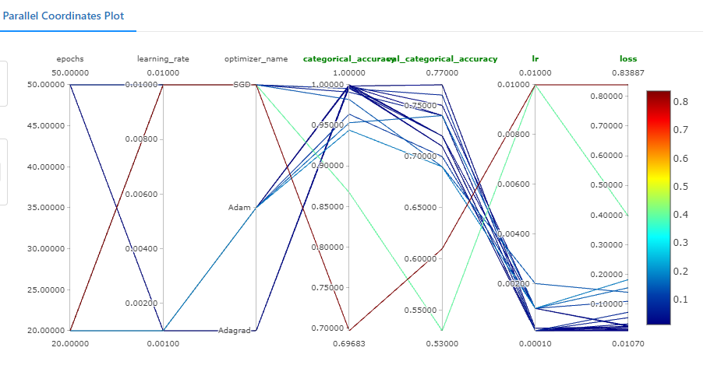

From the parallel coordinate plot, we can see that higher number of epochs (50), lower learning rate (0.001),lower lr factor, Optimizer Adam & Adagrad performed very well.

**Best vs Worst with respect to Loss**

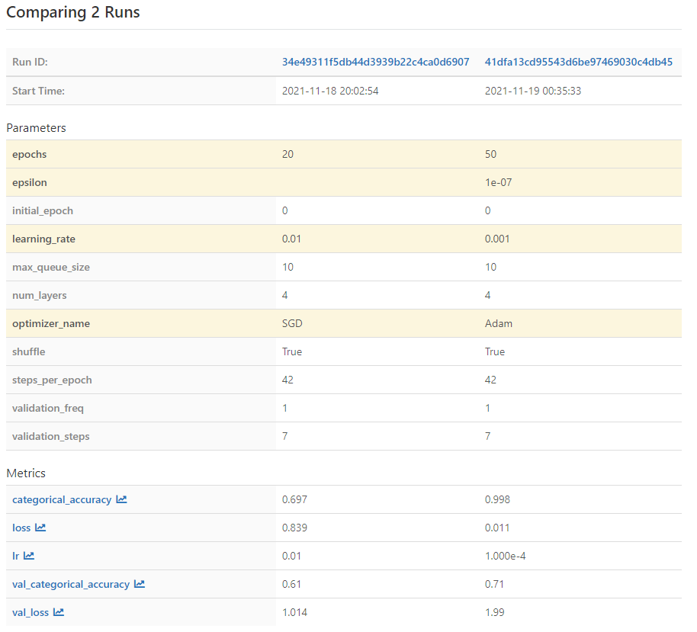

**Best vs Worst with respect to Validation categorical accuracy**

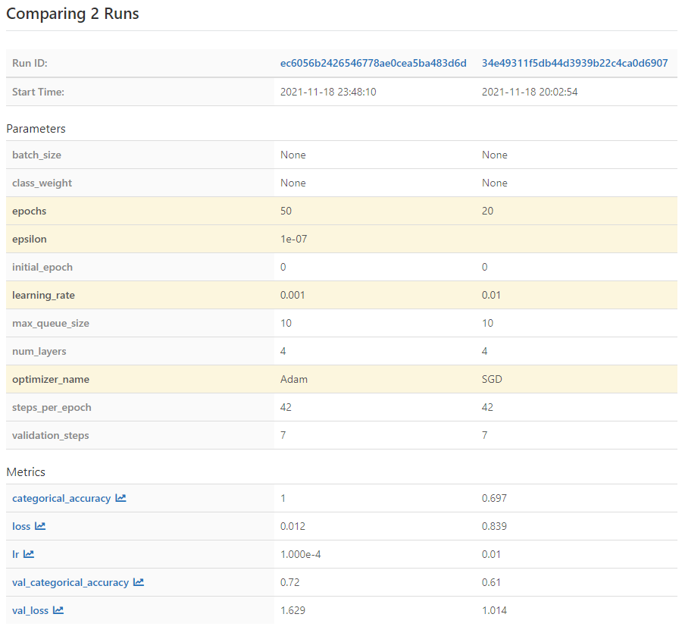

~***~

**Appendix**

**experiments-conv3d.json**

{

"parameters": [

{

"learningRateFactor": "0.1",

"minimumLearningRate": "0.0001",

"numberOfEpochs": "20",

"optimizer": "SGD",

"title": "Experiment - 1"

},

{

"learningRateFactor": "0.15",

"minimumLearningRate": "0.0001",

"numberOfEpochs": "20",

"optimizer": "SGD",

"title": "Experiment - 2"

},

{

"learningRateFactor": "0.20",

"minimumLearningRate": "0.0001",

"numberOfEpochs": "20",

"optimizer": "SGD",

"title": "Experiment - 3"

},

{

"learningRateFactor": "0.1",

"minimumLearningRate": "0.0001",

"numberOfEpochs": "50",

"optimizer": "SGD",

"title": "Experiment - 4"

},

{

"learningRateFactor": "0.15",

"minimumLearningRate": "0.0001",

"numberOfEpochs": "50",

"optimizer": "SGD",

"title": "Experiment - 5"

},

{

"learningRateFactor": "0.20",

"minimumLearningRate": "0.0001",

"numberOfEpochs": "50",

"optimizer": "SGD",

"title": "Experiment - 6"

},

{

"learningRateFactor": "0.1",

"minimumLearningRate": "0.0001",

"numberOfEpochs": "20",

"optimizer": "Adagrad",

"title": "Experiment - 7"

},

{

"learningRateFactor": "0.15",

"minimumLearningRate": "0.0001",

"numberOfEpochs": "20",

"optimizer": "Adagrad",

"title": "Experiment - 8"

},

{

"learningRateFactor": "0.20",

"minimumLearningRate": "0.0001",

"numberOfEpochs": "20",

"optimizer": "Adagrad",

"title": "Experiment - 9"

},

{

"learningRateFactor": "0.1",

"minimumLearningRate": "0.0001",

"numberOfEpochs": "50",

"optimizer": "Adagrad",

"title": "Experiment - 10"

},

{

"learningRateFactor": "0.15",

"minimumLearningRate": "0.0001",

"numberOfEpochs": "50",

"optimizer": "Adagrad",

"title": "Experiment - 11"

},

{

"learningRateFactor": "0.20",

"minimumLearningRate": "0.0001",

"numberOfEpochs": "50",

"optimizer": "Adagrad",

"title": "Experiment - 12"

},

{

"learningRateFactor": "0.1",

"minimumLearningRate": "0.0001",

"numberOfEpochs": "20",

"optimizer": "Adam",

"title": "Experiment - 13"

},

{

"learningRateFactor": "0.15",

"minimumLearningRate": "0.0001",

"numberOfEpochs": "20",

"optimizer": "Adam",

"title": "Experiment - 14"

},

{

"learningRateFactor": "0.20",

"minimumLearningRate": "0.0001",

"numberOfEpochs": "20",

"optimizer": "Adam",

"title": "Experiment - 15"

},

{

"learningRateFactor": "0.1",

"minimumLearningRate": "0.0001",

"numberOfEpochs": "50",

"optimizer": "Adam",

"title": "Experiment - 16"

},

{

"learningRateFactor": "0.15",

"minimumLearningRate": "0.0001",

"numberOfEpochs": "50",

"optimizer": "Adam",

"title": "Experiment - 17"

},

{

"learningRateFactor": "0.20",

"minimumLearningRate": "0.0001",

"numberOfEpochs": "50",

"optimizer": "Adam",

"title": "Experiment - 18"

},

{

"learningRateFactor": "0.1",

"minimumLearningRate": "0.0001",

"numberOfEpochs": "20",

"optimizer": "Nadam",

"title": "Experiment - 19"

},

{

"learningRateFactor": "0.15",

"minimumLearningRate": "0.0001",

"numberOfEpochs": "20",

"optimizer": "Nadam",

"title": "Experiment - 20"

},

{

"learningRateFactor": "0.20",

"minimumLearningRate": "0.0001",

"numberOfEpochs": "20",

"optimizer": "Nadam",

"title": "Experiment - 21"

},

{

"learningRateFactor": "0.1",

"minimumLearningRate": "0.0001",

"numberOfEpochs": "50",

"optimizer": "Nadam",

"title": "Experiment - 22"

},

{

"learningRateFactor": "0.15",

"minimumLearningRate": "0.0001",

"numberOfEpochs": "50",

"optimizer": "Nadam",

"title": "Experiment - 23"

},

{

"learningRateFactor": "0.20",

"minimumLearningRate": "0.0001",

"numberOfEpochs": "50",

"optimizer": "Nadam",

"title": "Experiment - 24"

}

]

}

**experiments-conv2d-CNN.json**

{

"parameters": [

{

"learningRateFactor": "0.1",

"minimumLearningRate": "0.0001",

"numberOfEpochs": "20",

"optimizer": "SGD",

"title": "Experiment - 1"

},

{

"learningRateFactor": "0.15",

"minimumLearningRate": "0.0001",

"numberOfEpochs": "20",

"optimizer": "SGD",

"title": "Experiment - 2"

},

{

"learningRateFactor": "0.20",

"minimumLearningRate": "0.0001",

"numberOfEpochs": "20",

"optimizer": "SGD",

"title": "Experiment - 3"

},

{

"learningRateFactor": "0.1",

"minimumLearningRate": "0.0001",

"numberOfEpochs": "50",

"optimizer": "SGD",

"title": "Experiment - 4"

},

{

"learningRateFactor": "0.15",

"minimumLearningRate": "0.0001",

"numberOfEpochs": "50",

"optimizer": "SGD",

"title": "Experiment - 5"

},

{

"learningRateFactor": "0.20",

"minimumLearningRate": "0.0001",

"numberOfEpochs": "50",

"optimizer": "SGD",

"title": "Experiment - 6"

},

{

"learningRateFactor": "0.1",

"minimumLearningRate": "0.0001",

"numberOfEpochs": "20",

"optimizer": "Adagrad",

"title": "Experiment - 7"

},

{

"learningRateFactor": "0.15",

"minimumLearningRate": "0.0001",

"numberOfEpochs": "20",

"optimizer": "Adagrad",

"title": "Experiment - 8"

},

{

"learningRateFactor": "0.20",

"minimumLearningRate": "0.0001",

"numberOfEpochs": "20",

"optimizer": "Adagrad",

"title": "Experiment - 9"

},

{

"learningRateFactor": "0.1",

"minimumLearningRate": "0.0001",

"numberOfEpochs": "50",

"optimizer": "Adagrad",

"title": "Experiment - 10"

},

{

"learningRateFactor": "0.15",

"minimumLearningRate": "0.0001",

"numberOfEpochs": "50",

"optimizer": "Adagrad",

"title": "Experiment - 11"

},

{

"learningRateFactor": "0.20",

"minimumLearningRate": "0.0001",

"numberOfEpochs": "50",

"optimizer": "Adagrad",

"title": "Experiment - 12"

},

{

"learningRateFactor": "0.1",

"minimumLearningRate": "0.0001",

"numberOfEpochs": "20",

"optimizer": "Adam",

"title": "Experiment - 13"

},

{

"learningRateFactor": "0.15",

"minimumLearningRate": "0.0001",

"numberOfEpochs": "20",

"optimizer": "Adam",

"title": "Experiment - 14"

},

{

"learningRateFactor": "0.20",

"minimumLearningRate": "0.0001",

"numberOfEpochs": "20",

"optimizer": "Adam",

"title": "Experiment - 15"

},

{

"learningRateFactor": "0.1",

"minimumLearningRate": "0.0001",

"numberOfEpochs": "50",

"optimizer": "Adam",

"title": "Experiment - 16"

},

{

"learningRateFactor": "0.15",

"minimumLearningRate": "0.0001",

"numberOfEpochs": "50",

"optimizer": "Adam",

"title": "Experiment - 17"

},

{

"learningRateFactor": "0.20",

"minimumLearningRate": "0.0001",

"numberOfEpochs": "50",

"optimizer": "Adam",

"title": "Experiment - 18"

}

]

}